**Abdul Ahmd Wani**

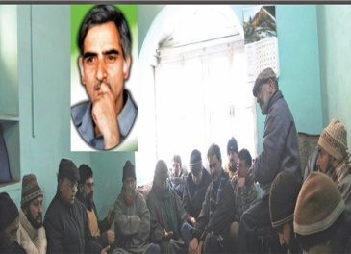

**About:** Jammu Kashmir Liberation Front (JKLF) chairman Muhammad Yasin Malik today paid rich tributes to Prof Abdul Ahad Wani on his martyrdom anniversary.

 Terming him as an exceptional personality, Malik while addressing a prayer meeting organised here to pay tributes to the deceased said,  “A struggle nurtured by the sacred blood of people like Shaheed-i-Danish  Prof Abdul Ahad Wani cannot be suppressed by any tyranny or oppression. Professor Wani was an exceptional personality who will always be remembered for his exemplary wisdom and unparallel sacrifices.”

Recalling the services, struggle and sacrifices of legendary Prof Abdul Ahmad Wani who was killed on on 31st December 1993, Yasin Malik said, “People like Wani actually add to the glory of nations. Intellectuals and thinkers like him, (Wani) are like jewel in the crown of nations and whenever history of Kashmir will be written his  name will be remembered with great honor and dignity. He was a great teacher, a prolific jurist, an innovative lawyer, a human rights champion, an ideologue, a diplomat and a social reformer who led Kashmiri nation on all these fronts and left his indelible impressions everywhere.”

**Murdered on:** 31st December 1993

**Attack details*:***He was a great teacher, a prolific jurist, an innovative lawyer.

**Reason to him target:** Abdul Ahmad Wani who was killed on on 31st December 1993, Yasin Malik said, “People like Wani actually add to the glory of nations. Intellectuals and thinkers like him, (Wani) are like jewel in the crown of nations and whenever history of Kashmir will be written his  name will be remembered with great honor and dignity.

**Occupation:** He was a great teacher, a prolific jurist, an innovative lawyer, a human rights champion, an ideologue, a diplomat and a social reformer who led Kashmiri nation on all these fronts and left his indelible impressions everywhere.”

**Belief:** A prolific jurist, an innovative lawyer, a human rights champion, an ideologue, a diplomat and a social reformer who led Kashmiri nation on all these fronts and left his indelible impressions everywhere.

**URL**:<https://www.greaterkashmir.com/news/kashmir/prof-abdul-ahad-wani-remembered-2/>

